ASSIGNMENT 1 OUTPUT

If number 1 is chosen, it displays information about “Shoes : Nike Flexisport”.

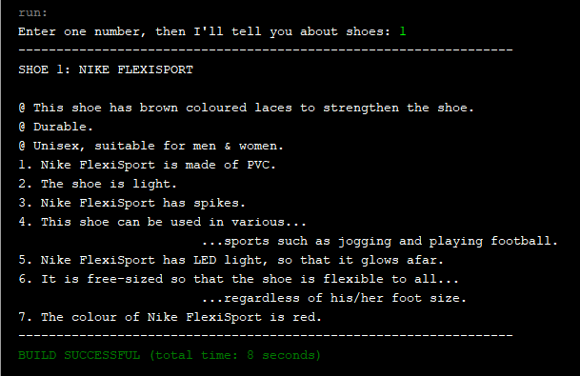

User enters number 2, it displays information about “Shoes : Mountain Boots”.

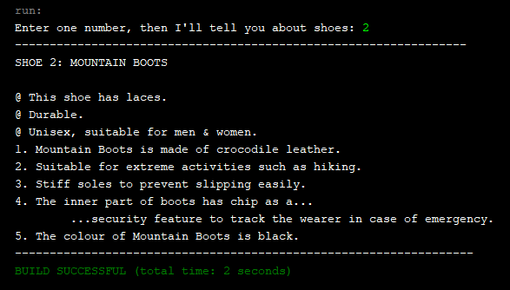

When number 3 is entered, details regarding “Shoe 3: Converse Shoes” are shown as below.

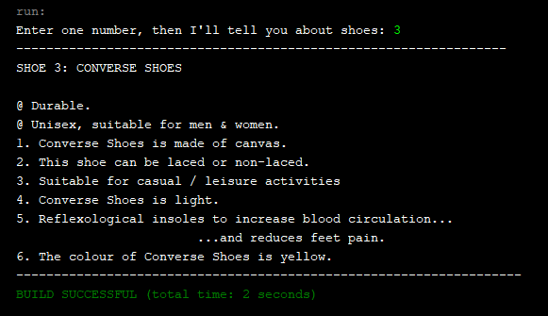

This occurs if user enters any numbers other than 1, 2 & 3.

